Project Outcome Documents

1. Prototype Availability & Repository Details
As the project involves a complex local machine learning environment requiring intensive compute for Stacking Ensemble models, the software is currently deployed and maintained as a Functional Local Prototype.

Complete source code, environment setup instructions, and the trained ensemble models are publicly available on GitHub. This repository serves as the official proof of the software's functional availability.
GitHub Repository URL: https://github.com/RushitT713/GreenLit-Go
Repository Status: Public

2. Technical Stack & Deployment Architecture
The prototype is a fully functional full-stack application divided into three running services:
- Frontend Client: React.js + Vite (Running on localhost:5173)
- Backend API: Node.js + Express + MongoDB Atlas (Running on localhost:5000)
- Machine Learning Service: Python + Flask serving the Stacking Ensemble predictor (Running on localhost:5001)

3. Proof of Concept (POC) Visual Evidence
Below is the visual evidence of the working software prototype, confirming its successful deployment and functional user interface.

- System Dashboard & Market Trends
The React frontend successfully fetching and displaying demographic insights and market trends from our 4000+ movie database via the Node.js backend.
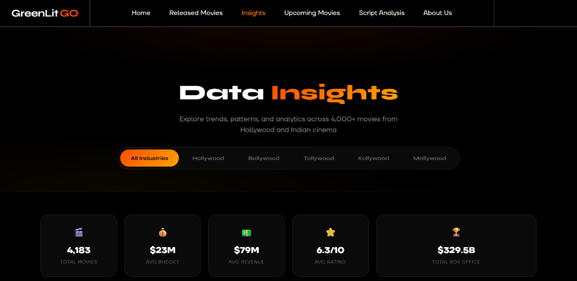
Figure - Insights Page – Hero

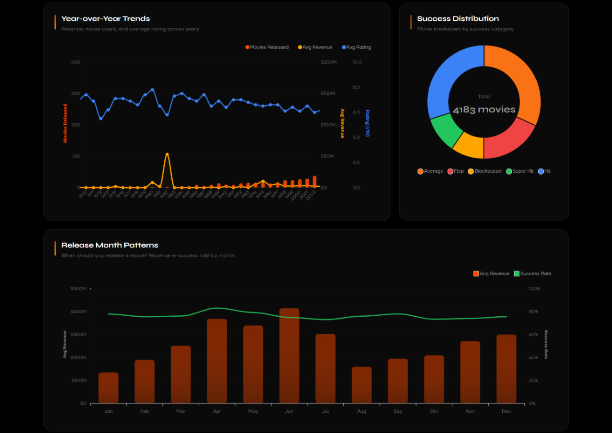
Figure - Insights Page - Insights
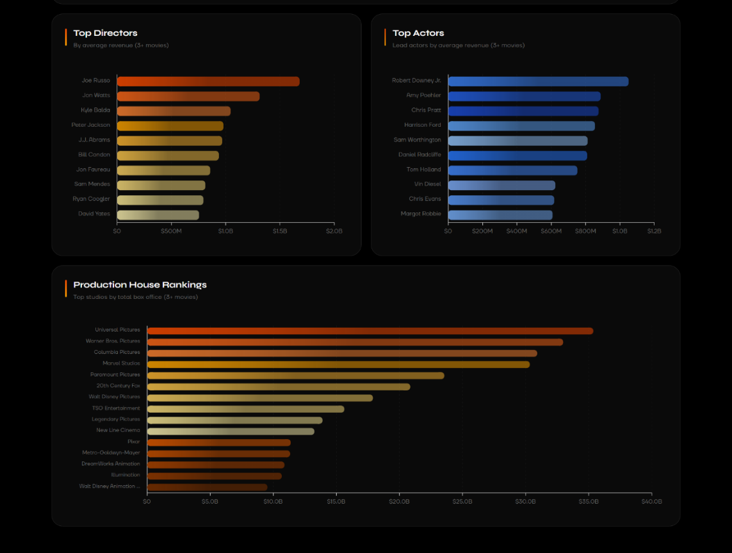
Figure - Insights Page - Insights
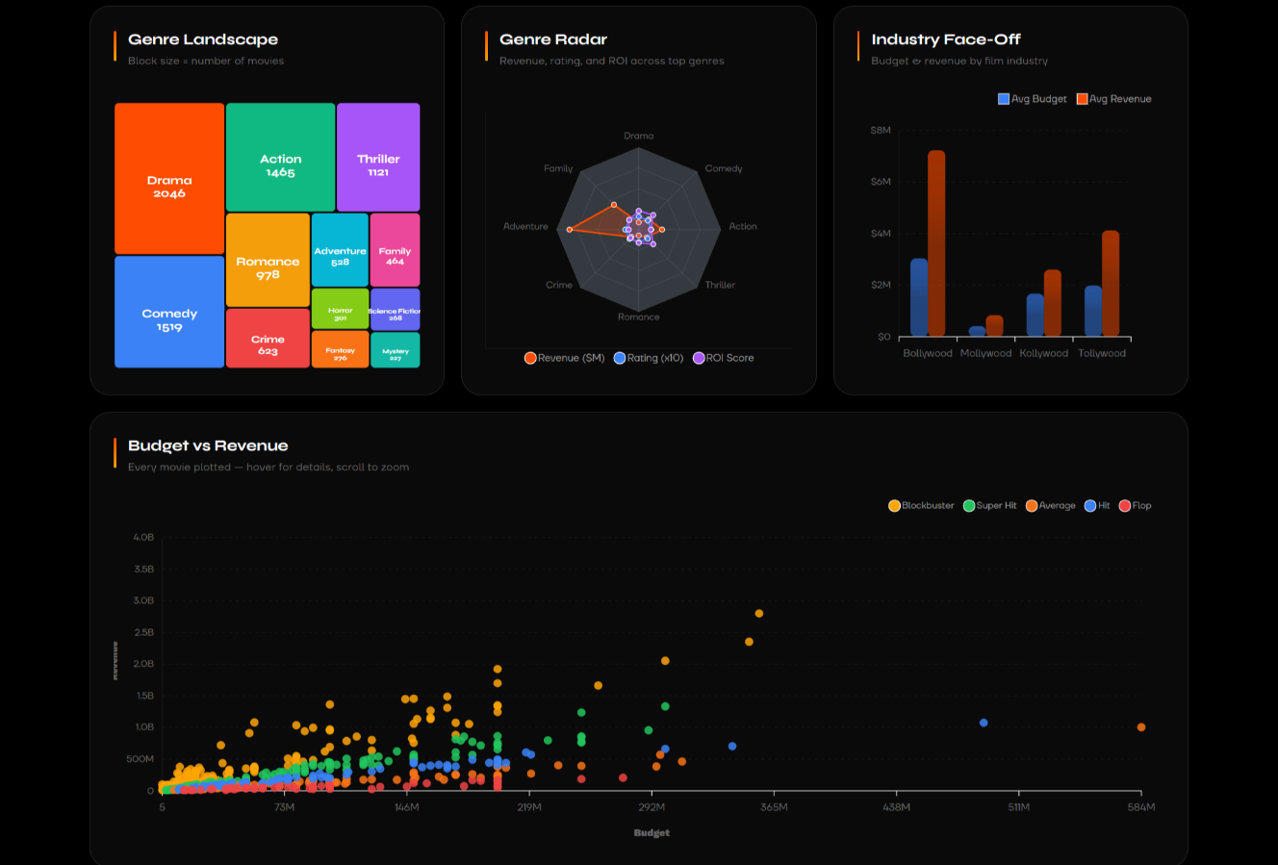
Figure - Insights Page - Insights

B. Machine Learning Prediction Engine
The Stacking Ensemble model executing inference on 46 engineered pre-release features to predict continuous revenue and output transparent SHAP (SHapley Additive exPlanations) charts.
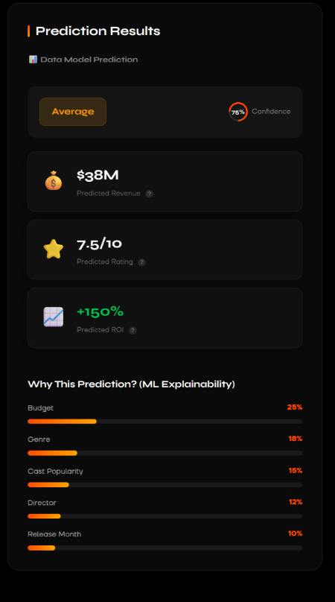
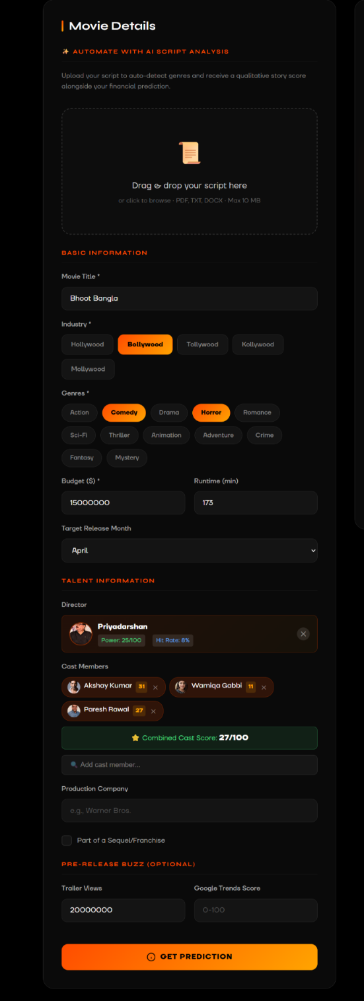
Figure - Upcoming Movies Page - Prediction Form and Prediction Output

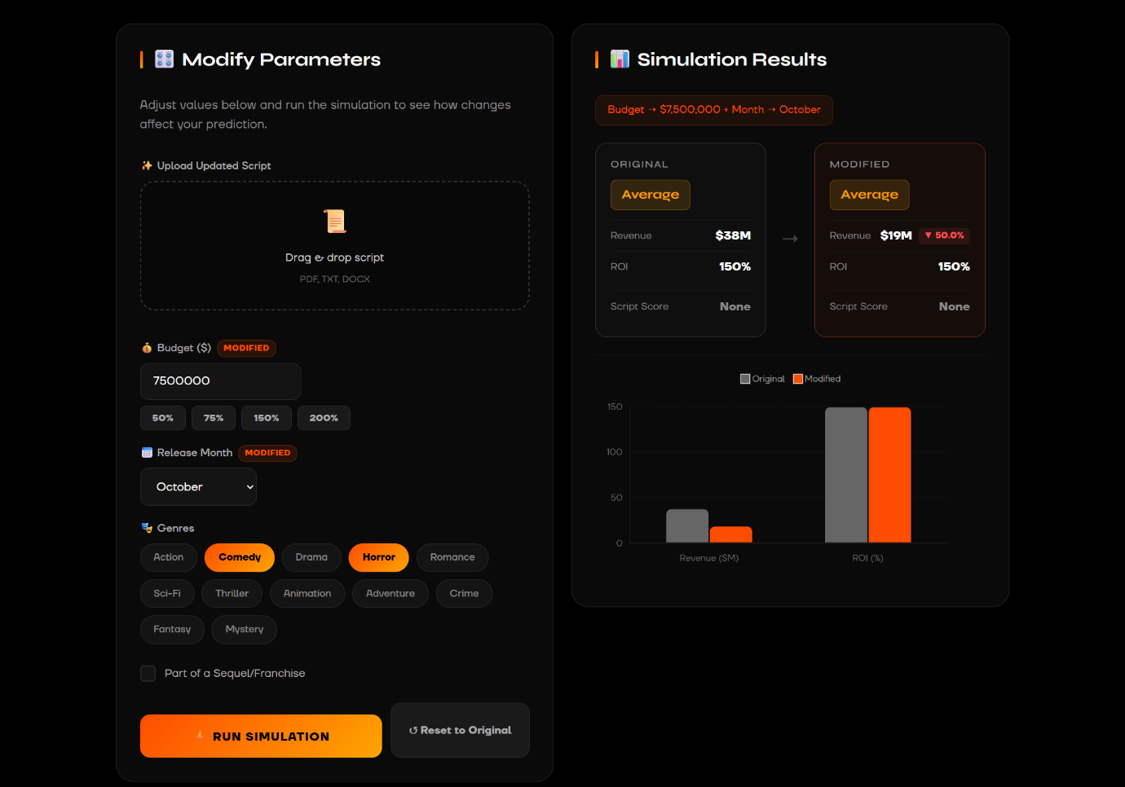
Figure - Upcoming Movies Page - What If Simulation

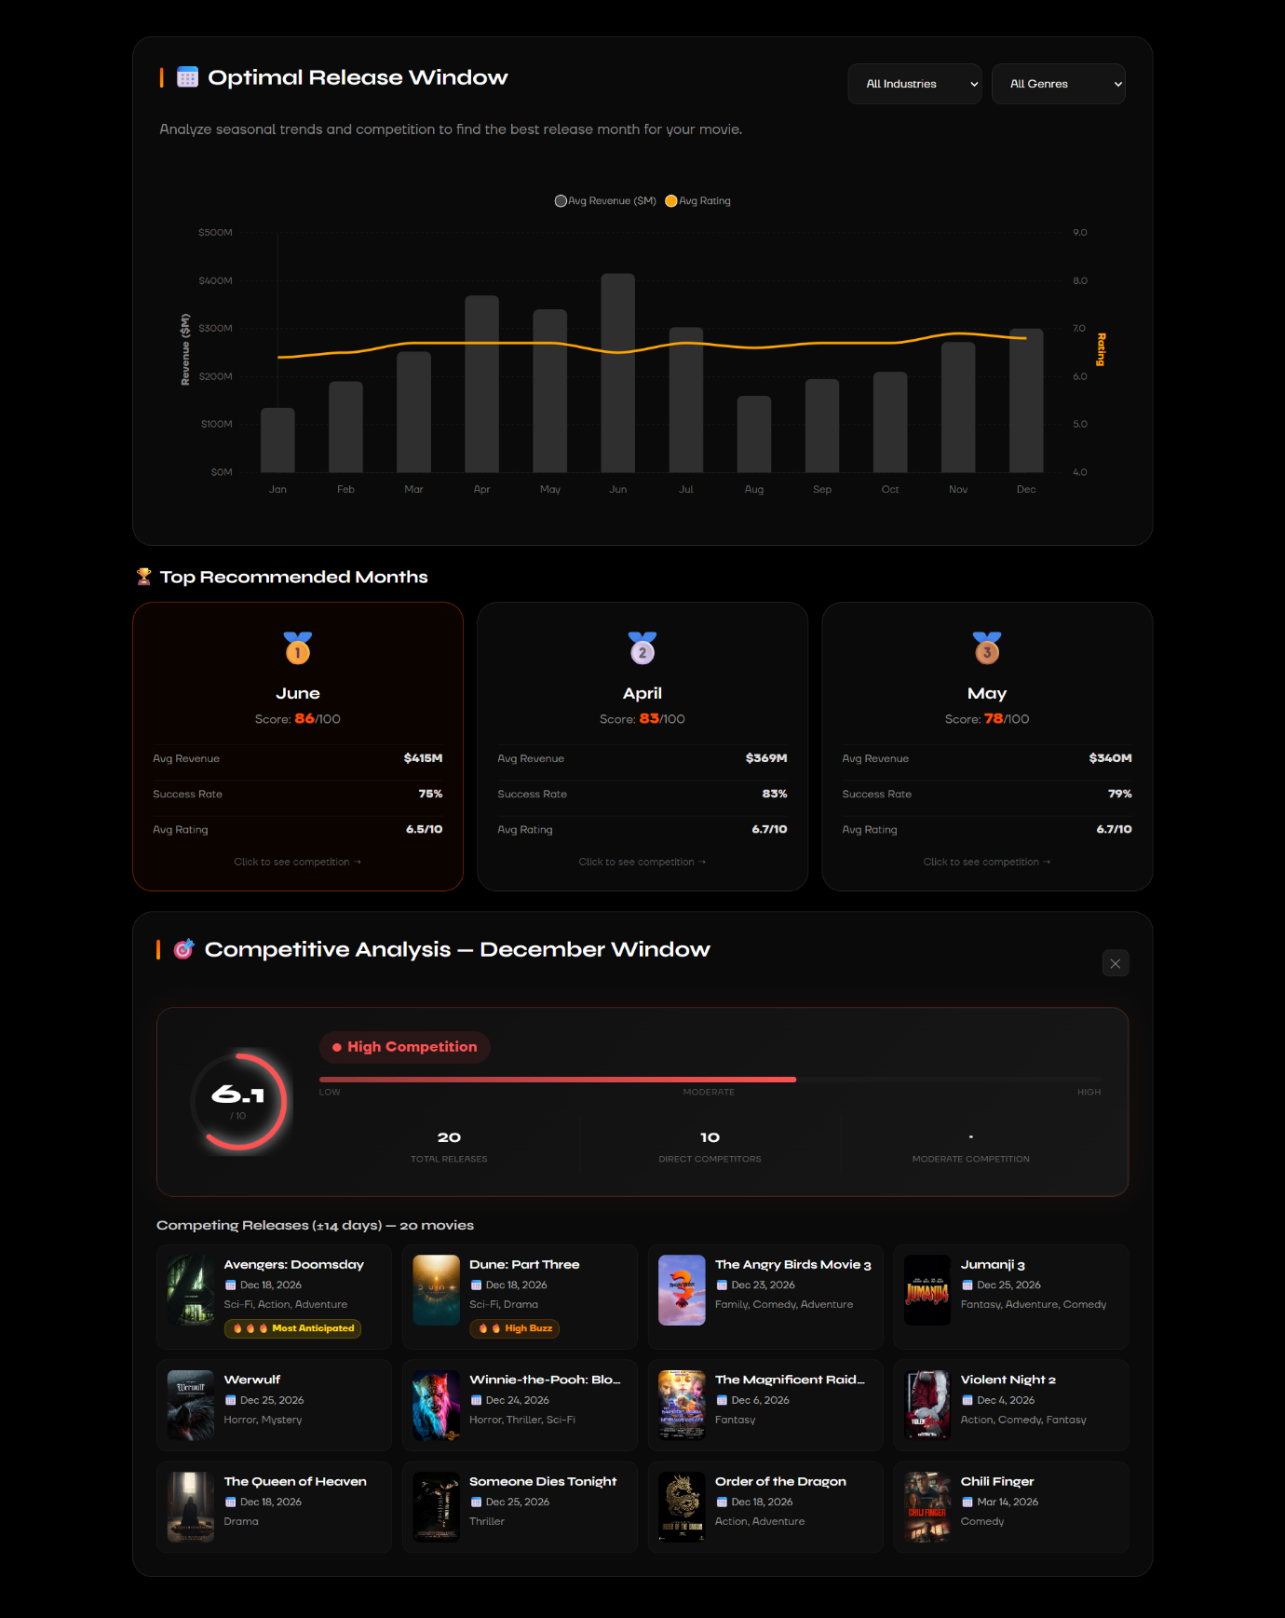
Figure - Upcoming Movies Page - Optimal Release

C. Generative AI Script Analysis
Integration with the Google Gemini API, successfully parsing a screenplay PDF and returning structured commercial viability metrics.

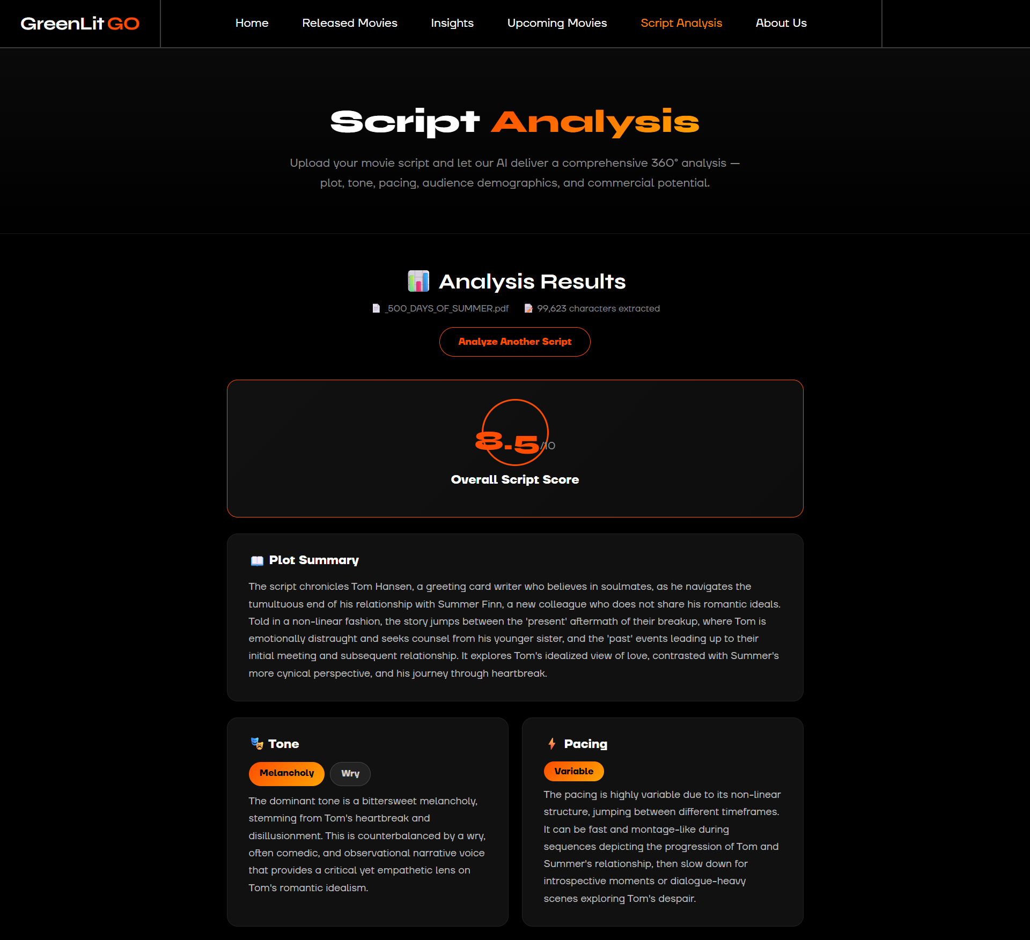

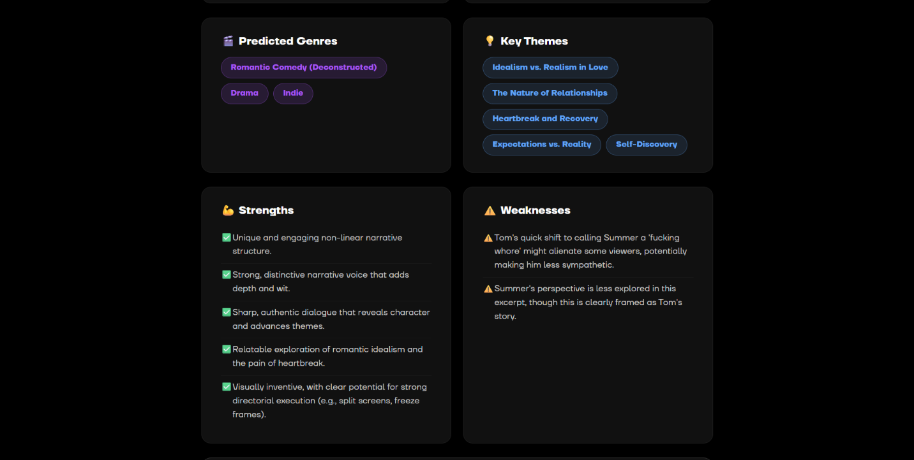

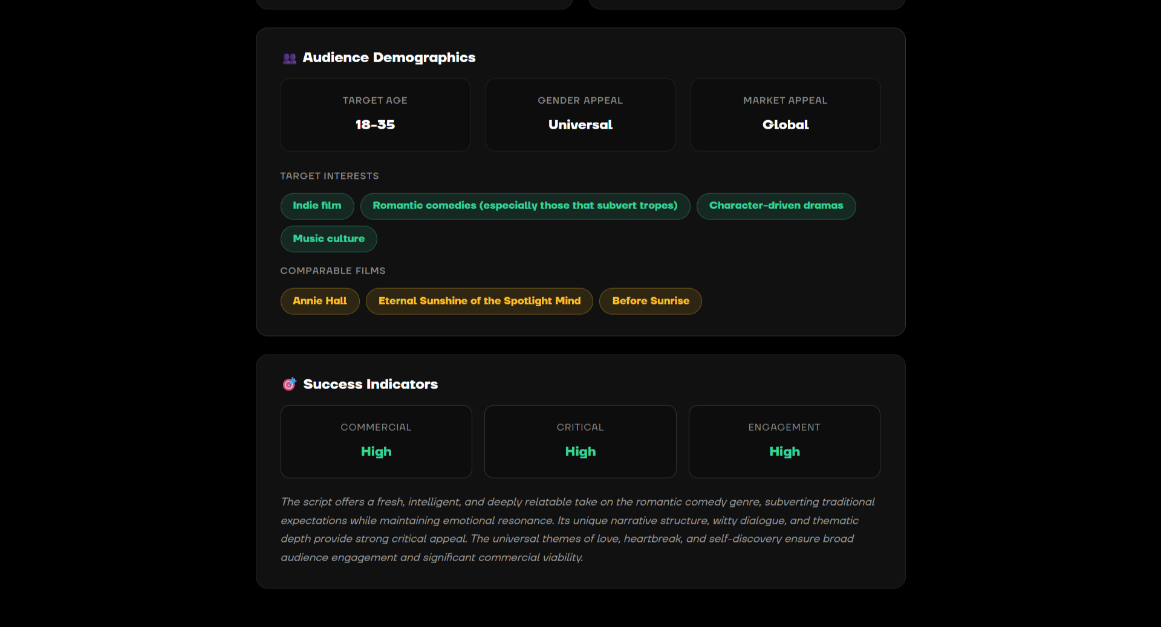

Figure - Script Analysis

D. Released Movies (Movie Library/User Recommendation System)
The React frontend successfully fetching and displaying movie library and get recommendations by user’s inputs from our 4000+ movie database via the Node.js backend.
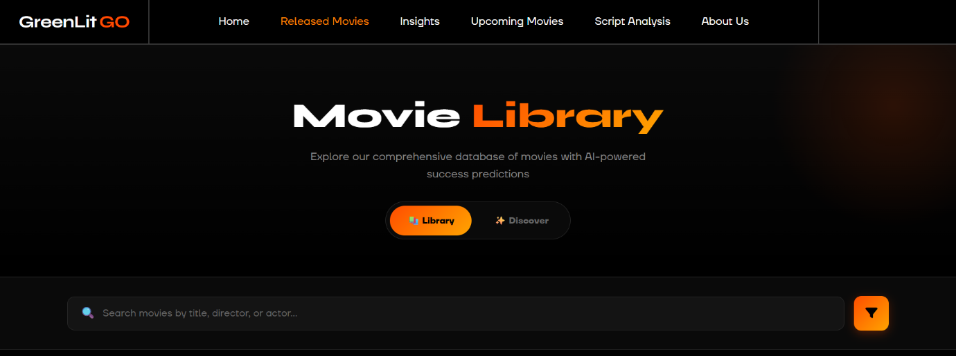
Figure - Released Movies Page – Her
o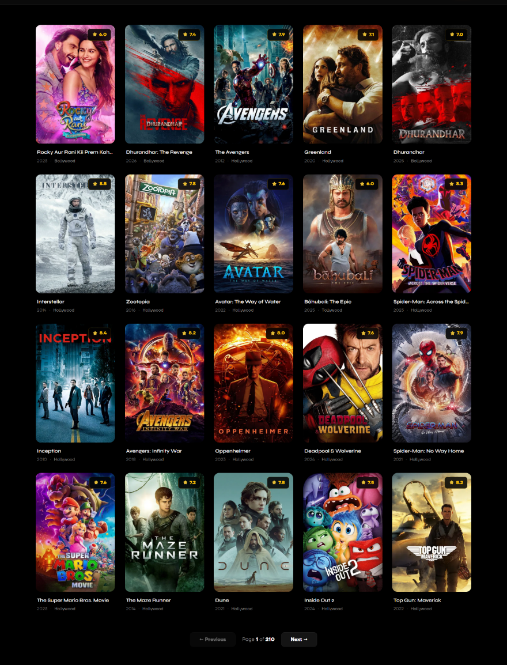
Figure - Released Movies Page - Movies Library

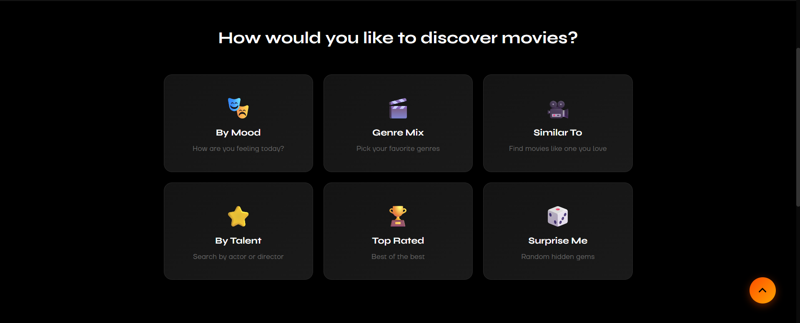
Figure - Released Movies Page - Discover (User Recommendation System)
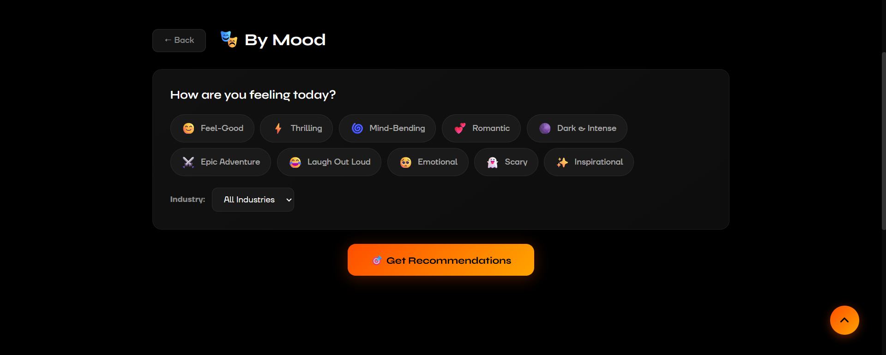
Figure - Released Movies Page - Discover (By Mood)
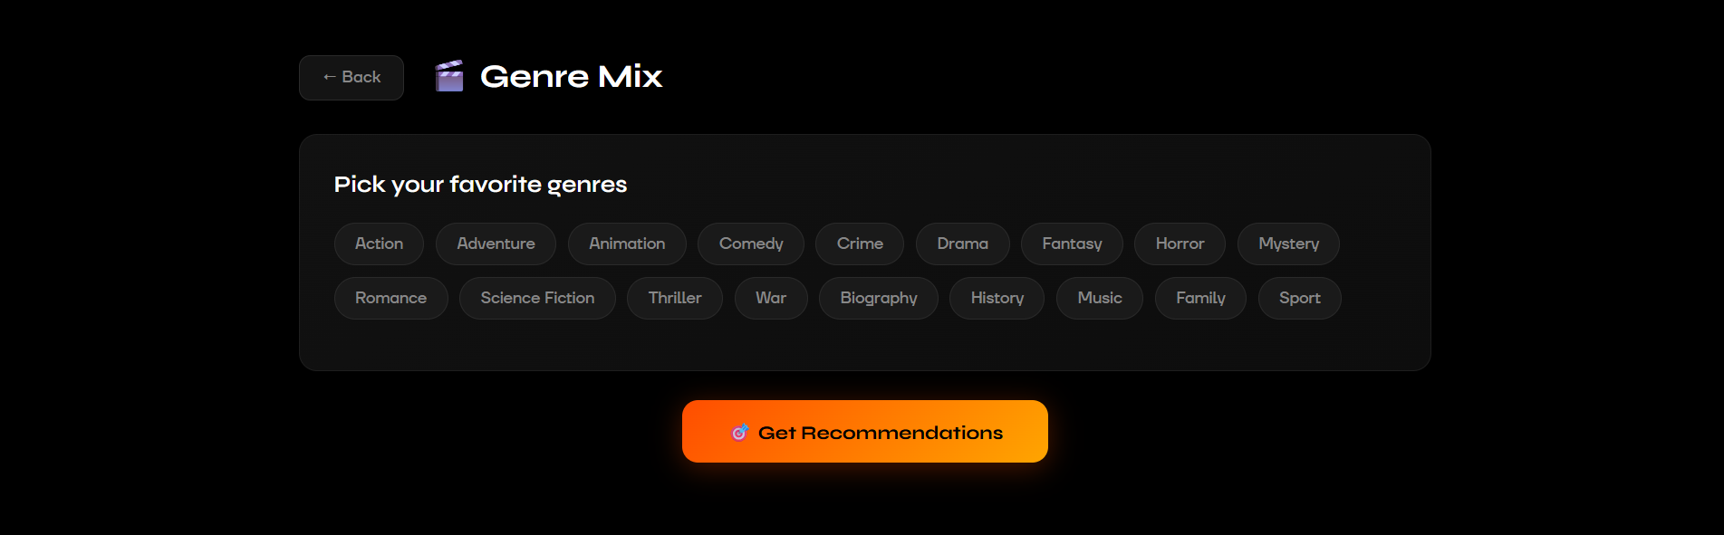
Figure - Released Movies Page - Discover (By Genre)
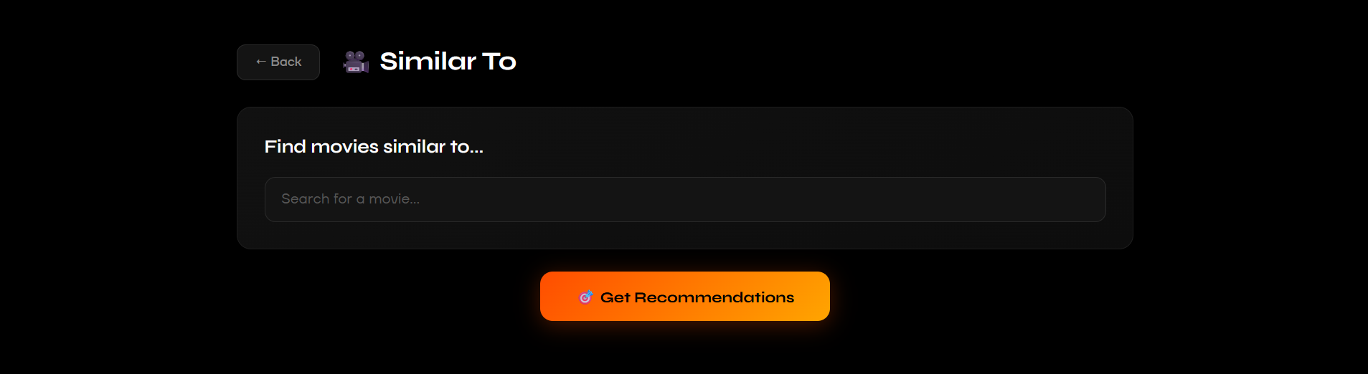
Figure - Released Movies Page - Discover (By Similar Movies)
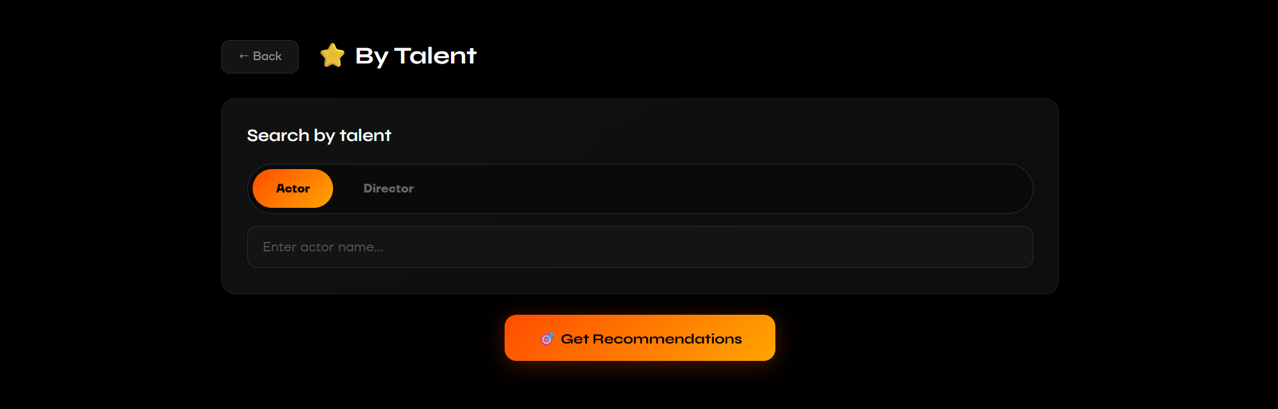
Figure - Released Movies Page - Discover (By Talent)
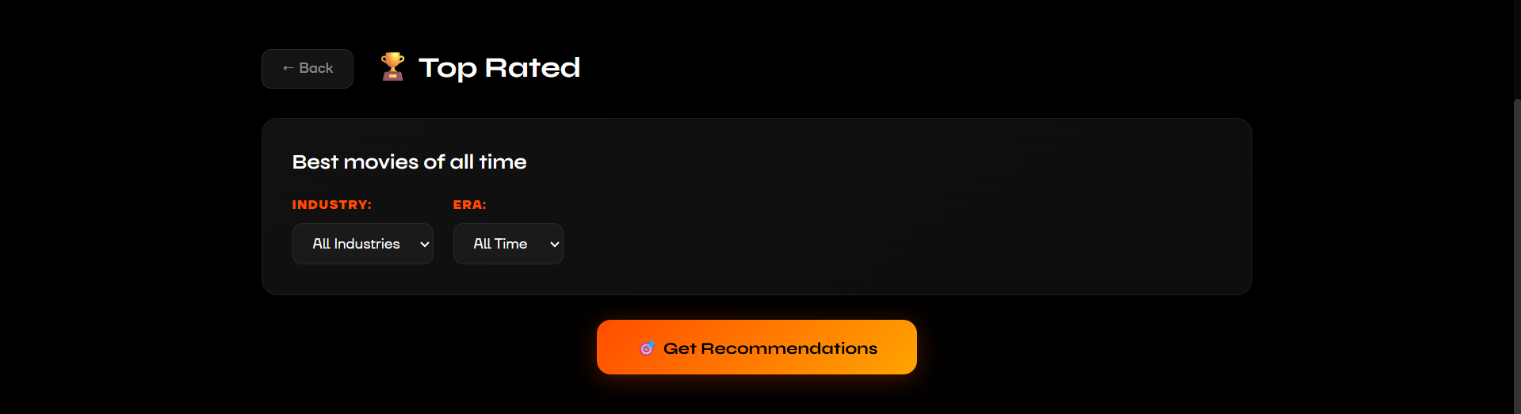
Figure - Released Movies Page - Discover (By Top Rated)
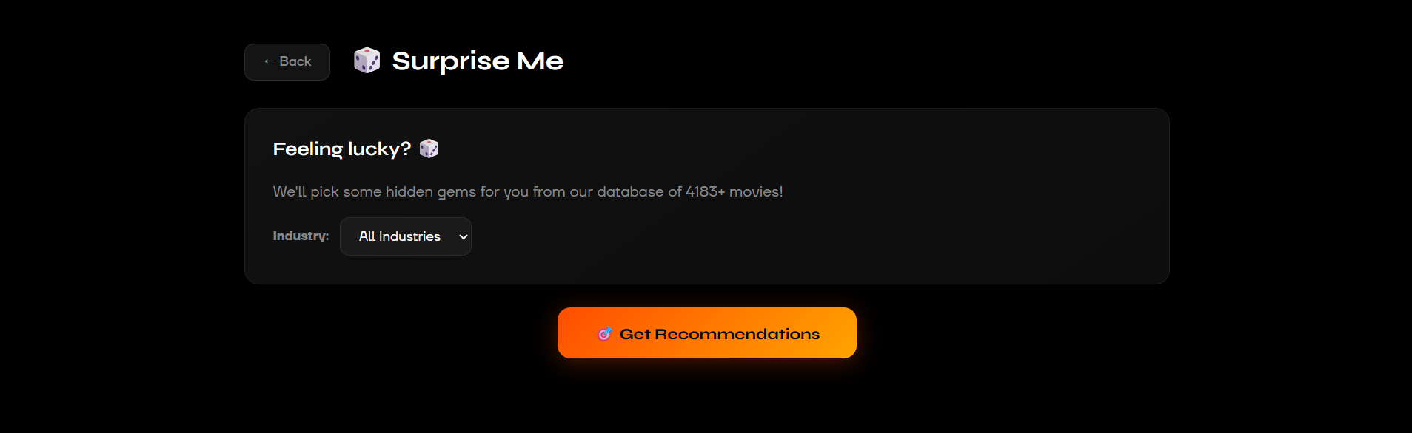
Figure - Released Movies Page - Discover (Suprise Me)

